Remembrance Trail

This trail is designed to follow our Remembrance session, so you will be starting outside Teaching Room 5. Turn left to walk to the end of the building and then left again to look at the end of the Concorde Room.

Find the date marker on the wall of this room. What date does it show? Why do you think this date is important at Duxford?

You are going to look around the site for other ways in which important dates and people are remembered. As you walk round, look for the benches that are placed all over the site. Can you find the names of 5 people whose names are on the benches?

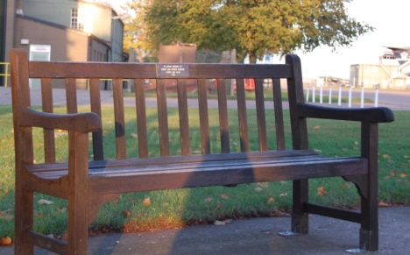

Turn right to walk towards the American Air Museum, past Hangar 4. As you come up to the American Air Museum, walk up the hill to the right of the building. You will find some glass panels. What pictures can you see on them?

Look carefully at the panels and see if you can answer these questions.

Are all the pictures of planes the same? YES NO

Why do you think the artist has drawn different types of planes?
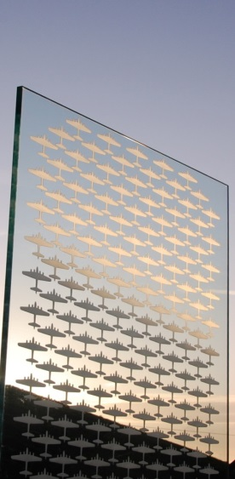

Who is the artist?

What is the sculpture called?

Why do you think it is called that?

Continue on down the slope towards the Land Warfare Hall. Before you get there, turn right down a pathway to the Royal Anglian War Memorial. Look carefully at the dates on the wall.

What is the first date recorded and what is the last?
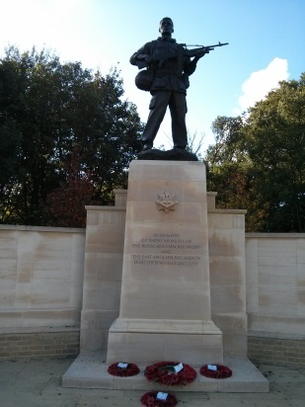

Are all the soldiers from the same regiment?

Why do you think the rest of the wall is blank?

The R.A.W.M. is a permanent reminder that people can see every time they come to Duxford. Do you think this is a good way to show that we remember people? Why?

This is the end of the trail, but if you keep your eyes open you may be able to spot other memorials around the site.
REMEMBRANCE
KEY STAGE 2

Wet Weather Remembrance Trail

If the weather is too bad for your group to do the regular trail please feel free to take a copy of it and use it on another occasion.

Meanwhile your group can still use this time to learn more about the First and Second World Wars by concentrating on the exhibits in Hangar 4 (Battle of Britain). To get there turn left out of the Schoolroom and walk along the road until you get to the doors at the rear of the Hangar. You may enter via these doors.

Once inside, spend a few minutes allowing the children to look at the exhibits at the rear of the Hangar, then guide the group to the front half of the building. Here you will find a number of exhibits from the First World War, including two aeroplanes, a mobile workshop and an aeroplane engine. You can then move onto exhibits dealing with the Home Front in the Second World War, which is also remembered on the 11th of November.

How many different civilian roles can the children spot? With your help they should be able to find an ambulance representing the medical services, a National Fire Service van representing the Fire Service, an ARP Warden, a member of the Observer Corps, people sheltering in an Anderson shelter and members of the Home Guard guarding a shot down Messerschmitt.

Look at the small exhibition stand behind the Anderson shelter. On two sides of the stands are photographs representing “The Many” – who are they? What did they do to help the war effort? Were the children involved in the war effort? What could they do to help?

