D-Day

On the 6th June 1944, the Allies invaded Normandy to take France back from occupation by Nazi Germany. During D-Day, and the Battle of Normandy and Operation Market Garden that followed, different regiments and forces played different roles. The invasion was the beginning of the end of the Second World War.
- Airborne Assault (AirSpace)

To the rear of the Aircraft Hall, near the Lancaster Bomber and Concorde is a museum of the Parachute Regiment. Go in through the set of electric doors.
Have a look at the recruitment posters at the beginning of the exhibition. How would you persuade men to join the Parachute Regiment?

Airspeed Horsa Glider under tow
© IWM (CH 10891)
Horsa Gliders were made of wood and had no engines. Instead, they were towed behind converted bomber aeroplanes and released when they had gained enough speed. Six of these aircraft carried the first airborne troops into Normandy just after midnight on the 6th June. Why was it better to send these troops in a glider rather than an aeroplane?

When troops are parachuted into a hostile country, they need to take all their supplies with them. Inside the Airborne Assault museum you will see some of the things that were dropped into Normandy. Make a list below of some of the things that were dropped.

- Land Warfare Hall
“Up 0500 hours; cold, wet, sea rough. This is it. Running for beach by 0700. Under fire by 0710.”
Chaplain Leslie Skinner
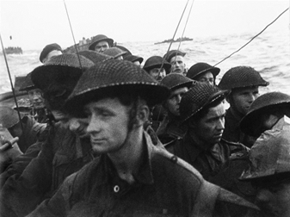
Commandos on a landing craft, Sword beach
© IWM (BU 1181)
Find the landing craft at the entrance to The Normandy Experience, to the rear of the Land Warfare Hall.

Sit in it for a moment, close your eyes and imagine you are there.

How might the infantry feel when they are on the landing craft waiting to run onto the beaches?

After D-Day, allied troops continued to fight through Normandy. Walk through the film room and into the display of the vehicles used in the Battle for Normandy. Here are the vehicles used to keep the allied army moving.

Match up the unit with their role and vehicle during the Battle for Normandy. Use the information blocks to help you.

Reconnaissance Corps | Supplying and transporting everything the army needs. | Ford F60L 3 Ton Truck
Royal Army Medical Corps | Locating the enemy and assessing its strength. Helping to plan attacks. | Daimler Mk1 Armoured Car
Royal Army Service Corps/Royal Army Ordnance | Running field dressing stations and hospitals. Treating the wounded. | BSA M20 Motorcycle
Royal Corps of Signals | Running communication between army units. | Austin K2 Ambulance

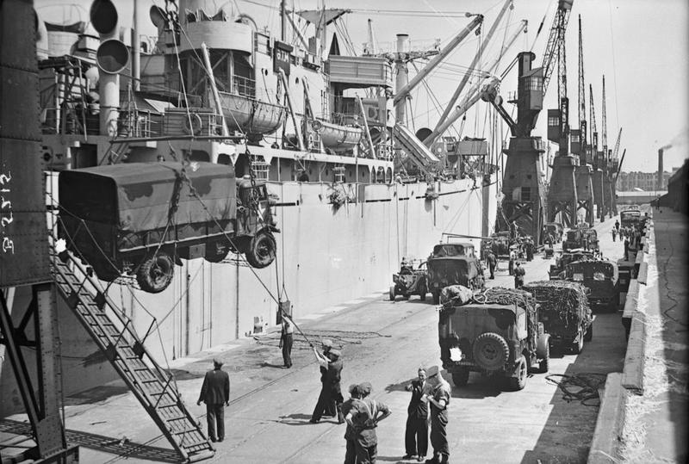
Vehicles being hoisted onto a ship, May 1944
© IWM (B 5215)
Did you know?
156, 000 troops and 10, 000 vehicles took part in D-Day. By the end of the Battle for Normandy, 700, 000 men, 100, 000 vehicles and 600, 000 tons of supplies had been transported to Normandy. The Allies had even built Mulberry harbour – an artificial harbour that was transported from England and meant that ships could dock to resupply the troops.
At the end of the Normandy exhibition there are some handling objects. Objects like these were taken to D-Day by infantry soldiers.

Draw one of the objects.

Label it to show what you can learn about it from handling it. You might label whether it is heavy or light, if it’s camouflaged, what material it’s made from, any special markings, what soldiers used it for…
As well as infantry and airborne forces, spies played an important role in the success of D-Day. The Special Operations Executive (SOE) had 1, 500 men and women in France who worked with tens of thousands of French Resistance fighters. Look at the case on the wall to the right of the SOE board. What did SOE do in Normandy?

- American Air Museum

Enter the American Air Museum and go down the ramp on the left side.
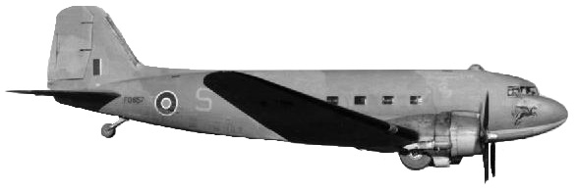
C 47 Skytrain/Dakota © IWM (CNA 3328)
Find the C-47 Skytrain/Dakota hanging from the ceiling. Look for the black and white stripes painted on its underside to show it was an Allied aeroplane that flew during D-Day.

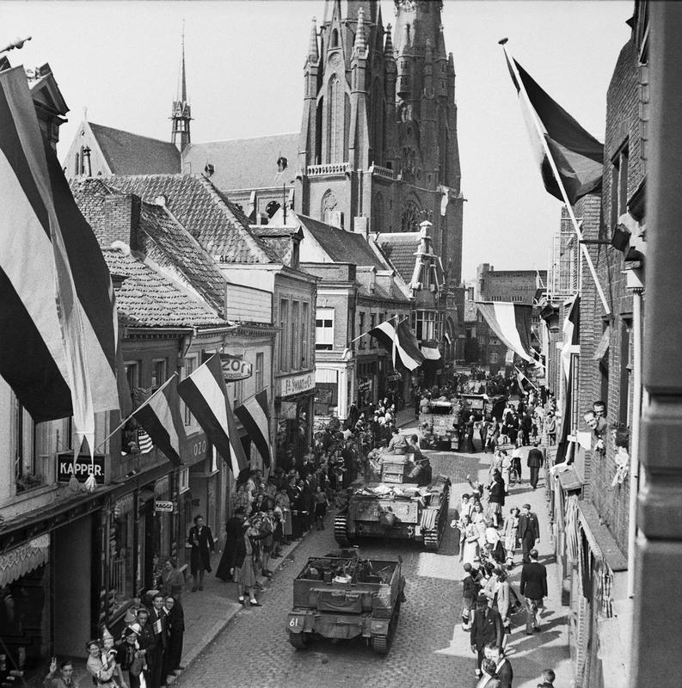
Crowds watch British tanks enter Eindhoven, Holland 18th September 1944 © IWM (BU 945)
These aeroplanes were used to transport airborne troops. Use the information board to fill in where this aeroplane was during the months stated below.

JUNE 1944 –

SEPTEMBER 1944 –

MARCH 1945 –

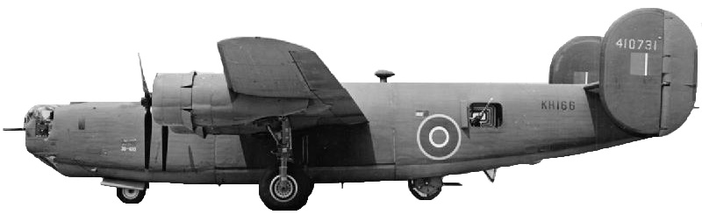
B-24 Liberator

If you have time, you could find the B-24 Liberator. This type of aeroplane was also used to drop airborne troops in Normandy.
When historical films are made, directors have to decide which parts of the story to include, what the miss out and have to try to avoid bias. If you had to tell the story of D-Day, what would you include?

Can you tell the story of D-Day in five sentences?

Teacher’s notes and answer sheet

Using the trail
We have tried to highlight the areas of the museum which are relevant to your talk and provide activities for the pupils to do there – there is no expectation that any one class or group will complete the whole trail! It is also not necessary to complete the trail in the order we have suggested, you could start at the American Air Museum or Land Warfare if you prefer.

You can choose to focus on any or all of:
AirSpace (Hangar 1) – 5 minutes from the Visitor Centre and where your talk will be held. This hangar is also where the Airborne Assault exhibition is.
The American Air Museum – about a 20 minute walk from the Visitor Centre.
The Land Warfare Hall (8 on your map) - 25-30 minutes from the Visitor Centre and home of the Normandy Experience.

If you would like to visit other hangars or cover topics outside your talk, please feel free to browse our other workshops and trails. You are welcome to use images and ideas from these trails to create your own trail – please keep copyright numbers with images where appropriate.

Answers
AirSpace – Posters show the uniform and machinery the troops would use, call them the ‘Red Devils’ and show the troops parachuting out of aeroplanes to make it look exciting. Gliders were used as they don’t have engines making noise so it was easier to invade at night without being noticed. There are lots of things on display that were dropped including: guns, bicycles, scooters, stretchers, trolleys and even Bing the mine-detecting dog.

Land Warfare Hall – Reconnaissance Corps - locating the enemy and assessing its strength and helping to plan attacks using a Daimler Mk1 Armoured Car. Royal Army Medical Corps - running field dressing stations and hospitals and treating the wounded, using an Austin K2 Ambulance. Royal Army Service Corps/Royal Army Ordnance - supplying and transporting everything the army needs using a Ford F60l 3 Ton Truck. Royal Corps of Signals - running communication between army units using a BSA M20 Motorcycle. SOE aimed to disrupt supply and communications, for example by derailing trains and used exploding train fog signals.

American Air Museum – The C47 Skytrain/Dakota in the American Air Museum was involved in Normandy in June 1944, Holland in September 1944 and the crossing of the Rhine in March 1945.

