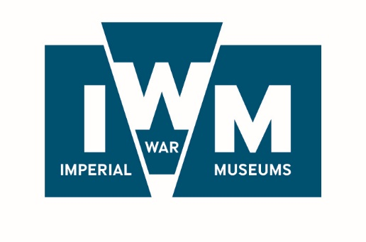

**IWM Collaborative Doctoral Partnership: HEI Proposal Form**

**DEADLINE – *deadline extended* - 5pm on Friday 6th December 2019**

**Please read the accompanying guidance document before completing this form**

|  |  |
| --- | --- |
| **Title of the proposal** | Click here to enter text. |

|  |  |
| --- | --- |
| **Contact details for proposed HEI supervisor/s** | |
| Name | Click here to enter text. |
| University/College | Click here to enter text. |
| Department/faculty/  school | Click here to enter text. |
| Position held | Click here to enter text. |
| Telephone number | Click here to enter text. |
| Email address | Click here to enter text. |

|  |  |
| --- | --- |
| **Has the Head of Department for each proposed HEI supervisor given consent for their involvement?** | Click here to enter text. |

|  |  |
| --- | --- |
| **Relevant experience of proposed HEI supervisor/s** | Maximum length is 250 words per named supervisor  Click here to enter text. |

|  |  |
| --- | --- |
| **Description of HEI Department/s** | Maximum length is 250 words  Click here to enter text. |

|  |  |
| --- | --- |
| **Contact details for HEI Research Office** | |
| Contact name: | Click here to enter text. |
| Telephone number: | Click here to enter text. |
| Email address: | Click here to enter text. |
| **Is your Research Office aware that this proposal is being submitted?** | Click here to enter text. |

|  |
| --- |
| **Summary of proposed development of topic** |
| Maximum length is 500 words  Click here to enter text. |

|  |
| --- |
| **Please outline any engagement, outreach, dissemination and impact initiatives that will be supported by the studentship:** |
| Maximum length is 500 words  Click here to enter text. |

|  |
| --- |
| **Please outline any professional development opportunities, including training that will support career development – either as aspects of the project that are ‘built in’ from the start or as opportunities that will be developed over the course of the project (it is expected that these opportunities would normally equate to between 3 and 6 months of project time)** |
| Maximum length is 500 words  Click here to enter text. |

|  |
| --- |
| **How will the HEI supervisors work with IWM for the benefit of the student?** |
| Maximum length is 500 words  Click here to enter text. |

|  |
| --- |
| **How did you find out about the CDP opportunities at IWM?** |
| Details circulated by my HEI  IWM website  Twitter  Facebook  [www.ahrc-cdp.org](http://www.ahrc-cdp.org) Word of mouth  Other (please specify): Click here to enter text. |

Signed Click here to enter text. Date Click here to enter a date.

**INSTRUCTIONS FOR SUBMISSION**

1. Please send this form as an email attachment to Hannah Wills, Research Manager at: [research@iwm.org.uk](mailto:research@iwm.org.uk) with the subject line appearing as ‘[University name], CDP proposal’ and including as additional attachments:
   1. a CV for the proposed HEI supervisor/s
2. All documents should be submitted in an MS Word format or as a PDF if that is not possible.
3. Attachments must not exceed 2Mb in size.
4. If this form has not been completed by the proposed supervisor, s/he must also provide evidence that s/he is aware of and has consented to the application being made in her/his name.
5. Should you have any general queries regarding the CDP application process, please contact Hannah Wills, Research Manager, on: 020 7416 5461 or at: [research@iwm.org.uk](mailto:research@iwm.org.uk).
6. Completed forms must be received in the IWM Research Department by 5pm on Friday 6 December 2019. Please note that in the interest of fairness we are not able to accept applications received after this time.