Forces of Flight
Explore Airspace and the upstairs interactive area, and try out the hands on exhibits.

Fill in the blank spaces to show in which direction the four forces of flight are.
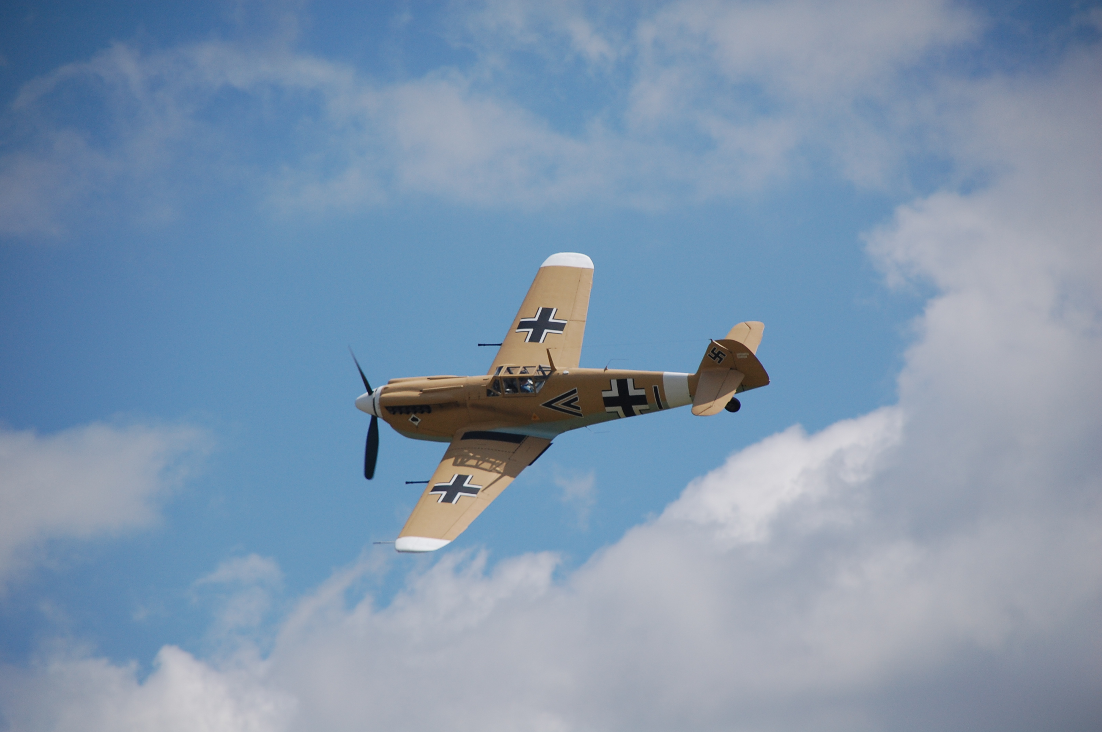

LIFT DRAG THRUST GRAVITY

Talk to your friends. Which parts of the aeroplane create LIFT and THRUST ?

In order to fly in the air, aeroplanes need to balance the four FORCES OF FLIGHT.

FILL in the missing words in the following sentence:

All aeroplanes need to overcome the FORCE of ___________ because that pulls things down.

The _________ creates __________ and so the aeroplane can go UP in the air.

The shape of the aeroplane is important because _________ is the FORCE that pulls things back.

The ______ provides ___________, therefore the aeroplane goes FORWARD.

Choose two aircraft that you think have a lot of DRAG?
Then choose two aircraft that have a lot less DRAG.
1.
2.

3.
4.

Find this airplane in the Airspace hangar. Have a look at its shape and highlight which parts you think will cause drag.
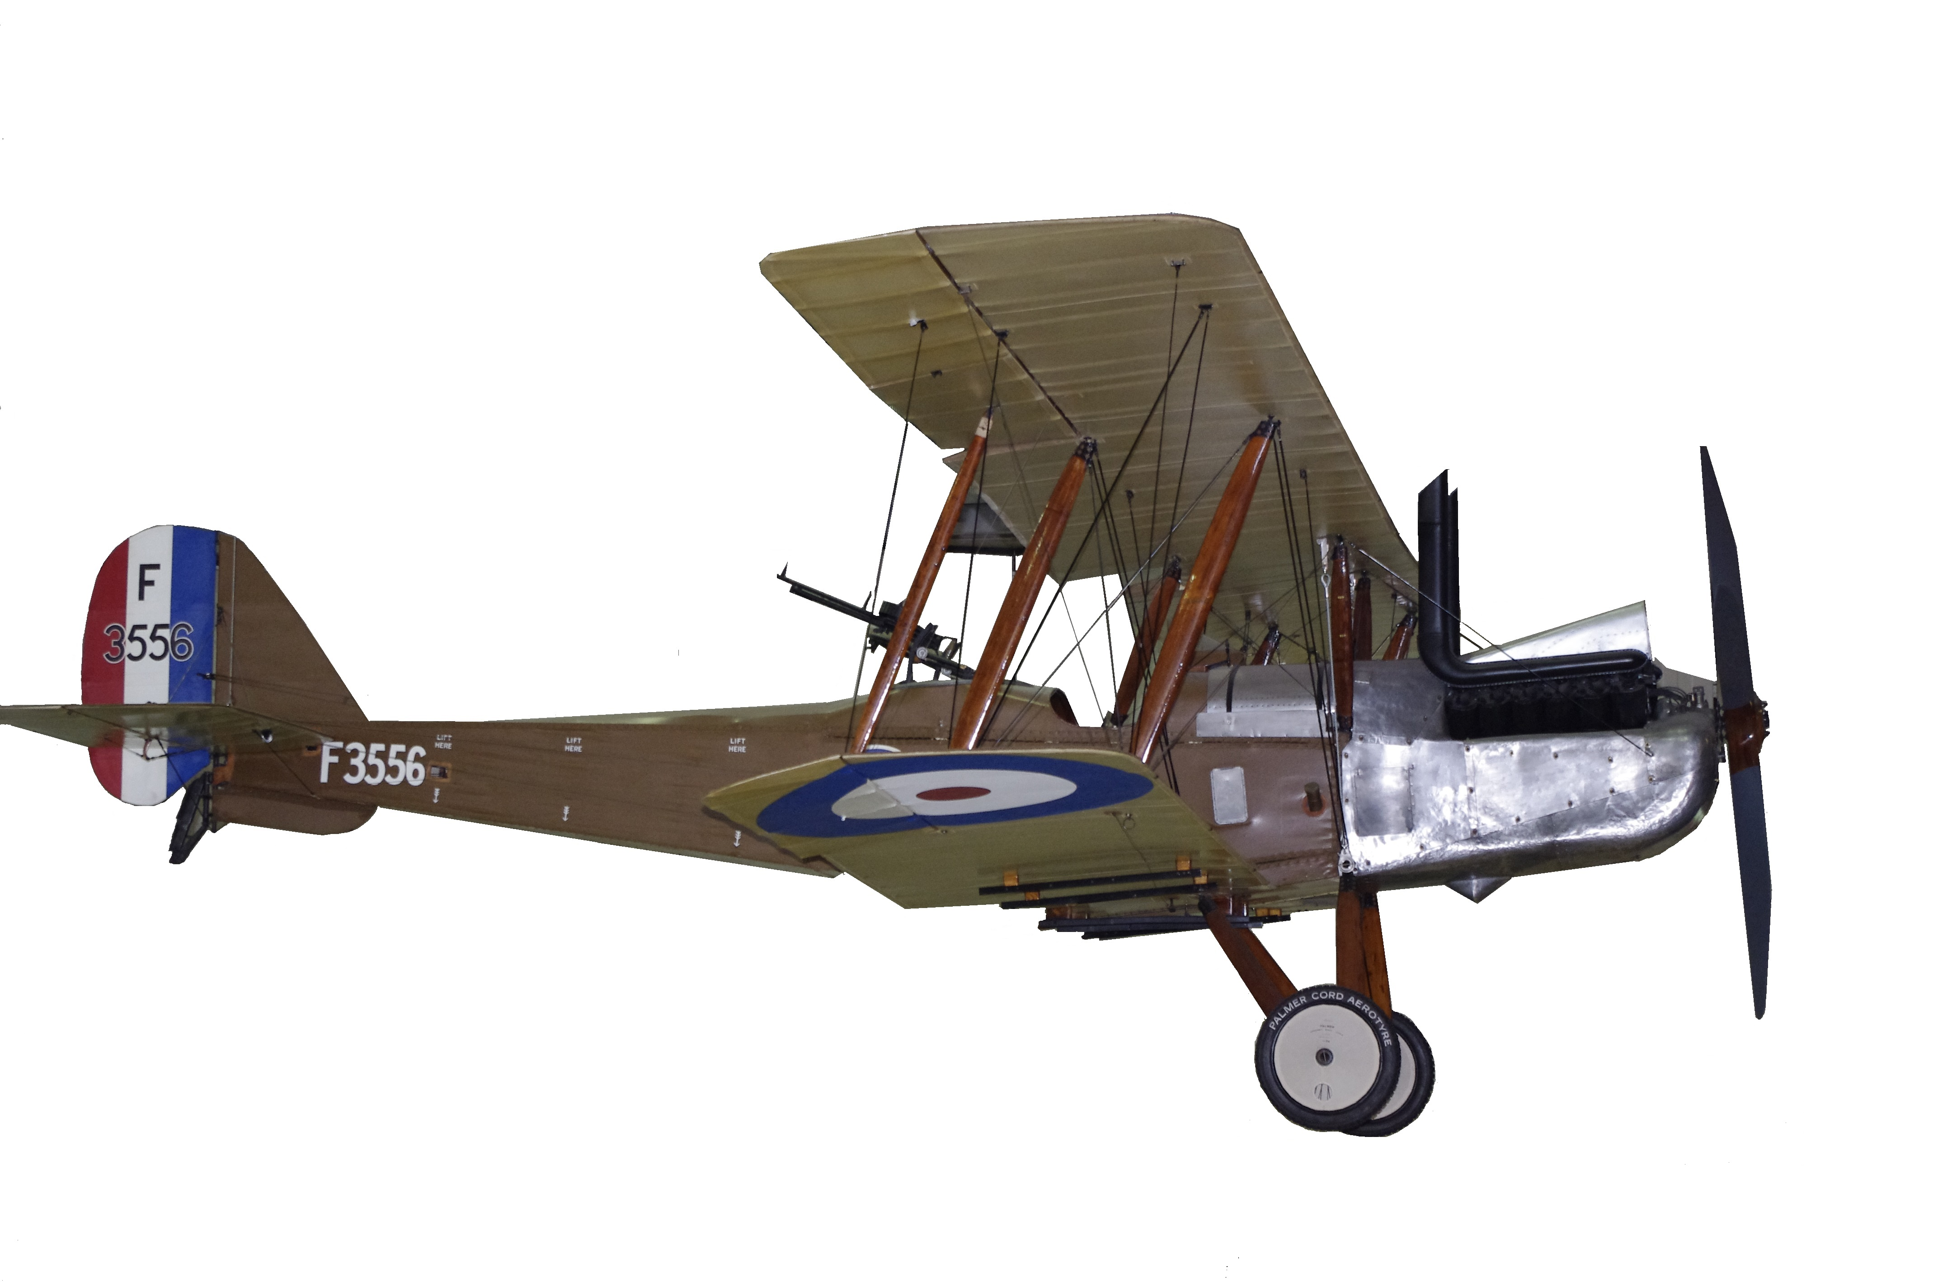

FORCES OF FLIGHT:
Teachers’ notes and answer sheet

Using the trail
- As the site is so large, we have concentrated this trail on the AirSpace hangar. There are plenty of aeroplanes to look at and talk about in other hangars as well.
- If you would like to visit other hangars or cover topics outside your talk, please feel free to browse our other sessions and trails.
- You are welcome to use images and ideas from these trails to create your own trail – please keep copyright numbers with images where appropriate.

Answers to the trail
Most of the questions are open-ended, so any reasonable answer will do.

LIFT

DRAG
THRUST

GRAVITY

The four forces are lift, drag, thrust and gravity.
The shape of an aeroplane’s wing is important because it creates lift for the aeroplane.

In order to fly in the air, aeroplanes need to balance the four FORCES OF FLIGHT.

FILL in the missing words in the following sentence:

All aeroplanes need to overcome the FORCE of GRAVITY because that pulls things down.

The WING creates LIFT and so the aeroplane can go UP in the air.

The shape of the aeroplane is important because DRAG is the FORCE that pulls things back.

The ENGINE provides THRUST, therefore the aeroplane goes FORWARD.

Choose two aircraft that you think have a lot of DRAG?
Then choose two aircraft that have a lot less DRAG.
1. SWORDFISH, LYSANDER, DH9, TIGER MOTH, RE8
2.

3. TSR2, CONCORDE, VULCAN, SPITFIRE, LIGHTNING
4.

Radiator and cooling system
Exposed cockpit area
SUGGESTED AREAS THAT CREATE DRAG
Undercarriage
Wires and struts

