The First World War
Duxford was originally built to train First World War pilots. Follow the trail to learn more about the First World War and the importance of a form of new technology – aeroplanes!

- AirSpace
Start off downstairs in AirSpace near to the Hastings and the Sunderland. There is a map at the beginning of the Aircraft Hall to show the position of the aircraft.
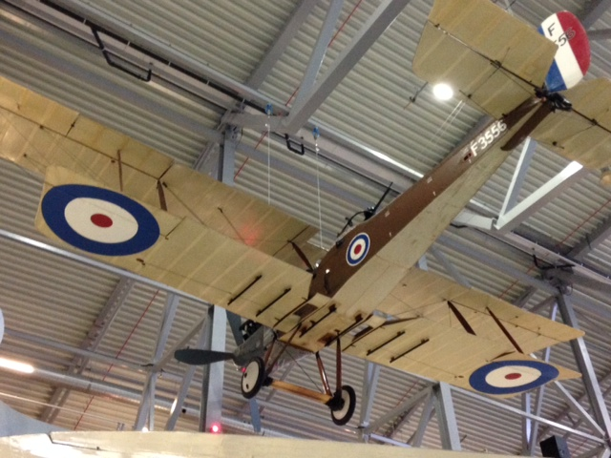
RE-8 at Duxford
Find the RE-8 suspended from the ceiling above the Trent engine. What was the RE-8’s nickname?

What was the RE-8’s role during the First World War?

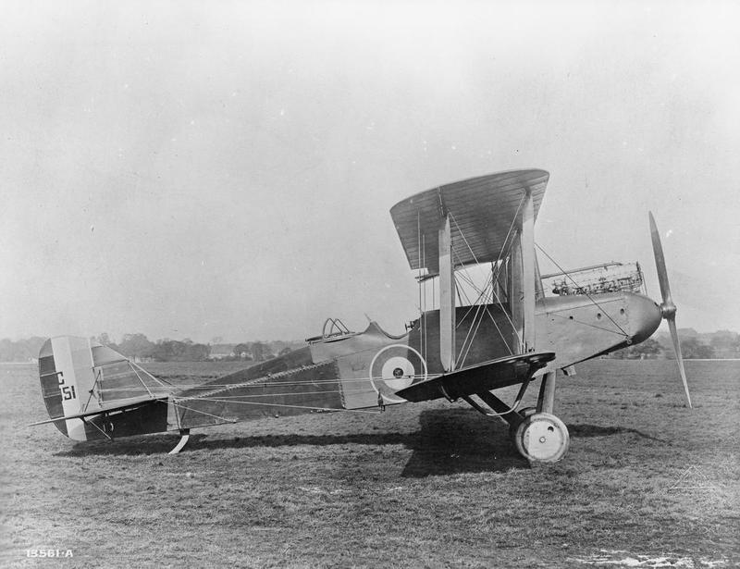
© IWM (Q 70119)
Look at the DH-9, between the Hastings and the Comet.
During the First World War, aeroplanes were used for the first time to attack cities. This DH-9 carried bombs in racks under its wings and was the first aeroplane to be stationed at Duxford.

Find three ways in which the DH-9 was vulnerable.

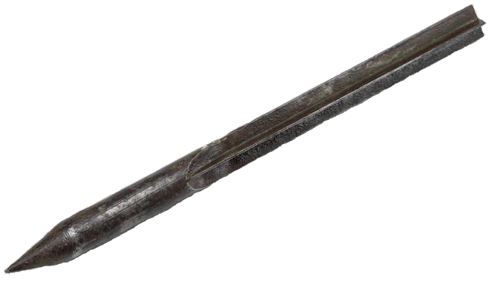
A flechette dropped from a German airship in 1915
© IWM (AIR 232)
Did you know?
Pilots dropped metal darts called flechettes from their aircraft onto targets below them.

Now walk to the Historic Duxford exhibition, which is close to Hangar 3.

- Historic Duxford
Duxford was originally built to be a training base for pilots in the First World War.
Flying goggles used at Duxford in 1918 © IWM (EQU 421)
Can you find the flying goggles?

Why did pilots in the First World War need to wear goggles?

Complete the brain puzzle.

What do you need to do in training to be a good pilot in the First World War? Write around the wings to explain your answer.

Pilots’ wings from the First World War
© IWM (INS 7505)

Now, walk to Hangar 4, the Battle of Britain hangar.
- Hangar 4
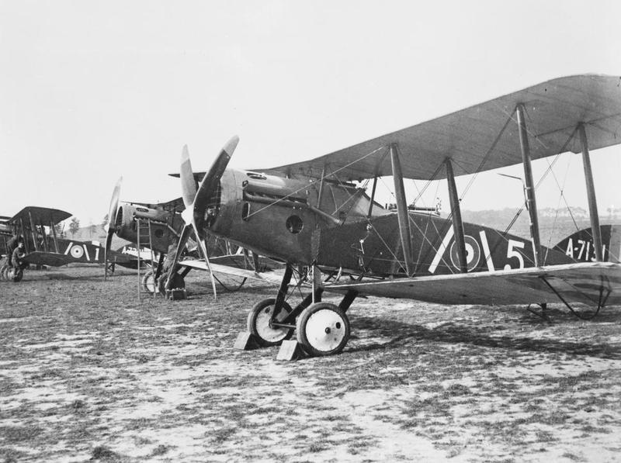
Bristol Fighter, September 1917
© IWM (Q 11677)
Read the information next to the Bristol F2B Fighter.

Circle the materials that the Bristol Fighter was made from.

WOOD METAL FABRIC PLASTIC

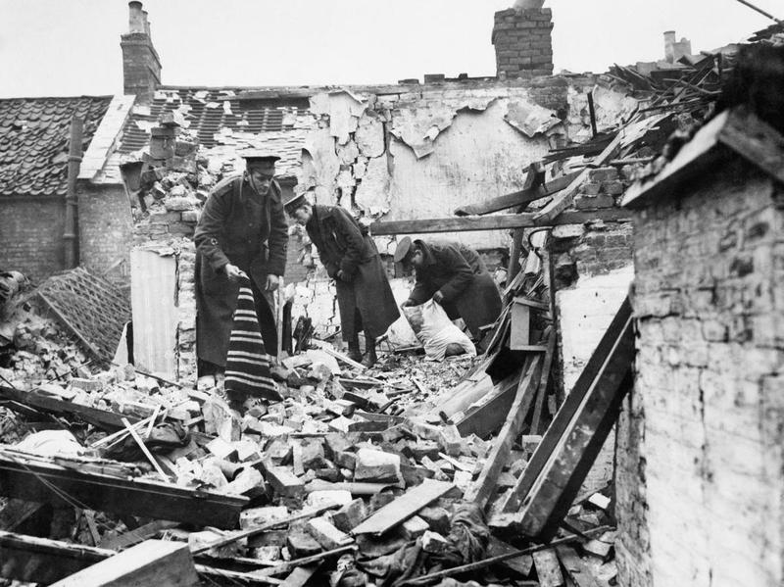
Soldiers clearing up after an air raid in King’s Lynn, 1915 © IWM (Q 53589)
In the First World War, both sides were using aircraft for the first time. Some aeroplanes were used for observation and others for bombing or as fighters. German forces also used Zeppelins, enormous hydrogen-filled air ships, to bomb England.

How did England defend itself from enemy aircraft?

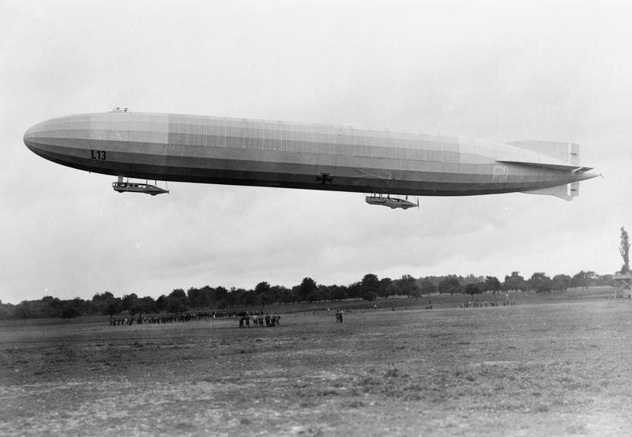
German Naval Airship L3 © IWM (Q 58456)

Now walk down to the Land Warfare Hall, marked Hangar 8 on the site map.
- Land Warfare Hall
The First World War was a war of new technology such as tanks and aeroplanes. Despite this, horses were still used on the front line too.
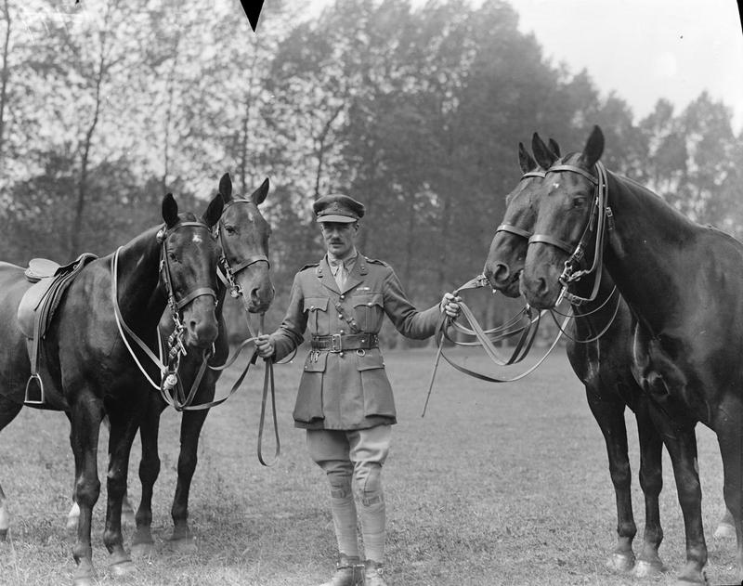
Part of the Royal Horse Artillery, June 1918 © IWM (Q 9022)

Find the pieces of equipment associated with horses. How useful were horses in the First World War?

Look at the soldiers at the beginning of the First World War section.
At the beginning of the First World War, French soldiers wore a blue and red uniform. The British soldiers wore khaki.

Which do you think is a better colour scheme to wear in the trenches?
First World War British steel helmet
© IWM (UNI 7930)

Why do you think that?

What did soldiers need steel helmets for?

Why are they shaped like this?

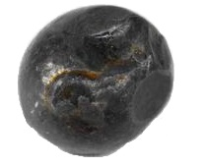
© IWM (EPH 9016

Did you know?
Some artillery shells contained shrapnel balls. Before 1916, soldiers were wearing cloth caps, which did not protect their heads at all.
Teachers’ notes and answer sheet

Using the trail
We have tried to highlight the areas of the museum which are relevant to your talk and provide activities for the pupils to do there – there is no expectation that any one class or group will complete the whole trail!

The trail is designed so that if it is printed double-sided, each worksheet will cover a specific area of the museum.

You can choose to focus on any or all of:
AirSpace (Hangar 1) – 5 minutes from the Visitor Centre and where your talk will be.
Historic Duxford – 5 minutes from the Visitor Centre.
Hangar 4 – 10-15 minutes from the Visitor Centre.
The Land Warfare Hall (8 on your map) - 25-30 minutes from the Visitor Centre, but home to most of our First World War artefacts so well worth a visit if you can.

If you would like to visit other hangars or cover topics outside your talk, please feel free to browse our other workshops and trails. You are welcome to use images and ideas from these trails to create your own trail – please keep copyright numbers with images where appropriate.

Answers
AirSpace – The RE-8 was nicknamed Harry Tate after a music hall comedian and was used for reconnaissance and observation. The DH-9 had underpowered and unreliable engines, was made of wood and fabric so did not protect the pilot, the cockpit was open so the pilot and observer were not protected and the cockpit made the observer sick.

Historic Duxford – Pilots wore goggles to protect their eyes from oil and debris. To be a good pilot you need to be a good soldier, learn to read maps, communicate in Morse Code, understand how the aircraft worked, take off and land successfully, fly solo and then train in combat flying (any or all of these are acceptable answers!).

Hangar 4 – The Bristol Fighter is made of wood and fabric. England defended itself from aircraft with fighter planes, anti-aircraft guns, search lights and observers.

Land Warfare Hall – Horses were not useful in battle but were very useful for moving ambulances, equipment, guns and men across the Western Front. Khaki is a better uniform choice as it is camouflaged. Soldiers wore steel helmets to protect their heads. They were shaped like that to deflect round shrapnel balls and the lip of the helmet helped to protect the rest of their body.

