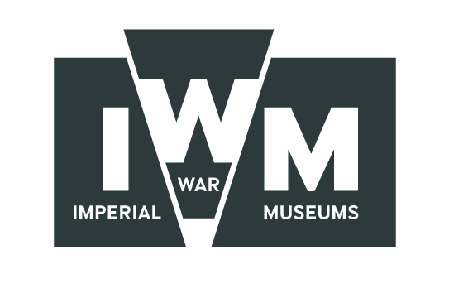
FILMING REQUEST FORM: IWM London / Churchill War Rooms / HMS Belfast

A SITE VISIT IN ADVANCE OF FILMING IS STRONGLY RECOMMENDED
Press Filming and Photography rates
IWM London | 1st hour £200+VAT | 2nd hour £150+VAT
Churchill War Rooms | 1st hour £300+VAT | 2nd hour £300+VAT
HMS Belfast | 1st hour £300+VAT | 2nd hour £300+VAT
Please note, at least one week’s notice is required for all filming onsite. To qualify for the Press Filming and Photography rates, the shoot must be no more than 2 hours.

Main Details:
Production Title:

Name of Organisation:

Date of filming:

Time of arrival & departure:

Contact Details
Contact Name:

Telephone Number:

Fax Number:

Email Address:

Filming Details
Please provide a brief summary of the content of the film and how the location will be credited during the piece.
Please provide details of the size of the crew.
Please state any specific areas or exhibits you wish to film:
Anticipated date of film release and broadcast outlet:

Additional information/requirements

Please return the form to us as soon as possible. We aim to respond to all filming requests within 24 hours.
Once completed please return to:

Press Office
Imperial War Museum
Lambeth Road
London
SE1 6HZ
Tel: 020 7416 5436
Fax: 020 7416 5436
Email: press@iwm.org.uk

